Management Agent with ORM Stack

Contents

1. Introduction 3
2. Workflow diagram to deploy the stack 3
3. Create stack for Management agent 4
4. Plan the Job 6
5. Apply the Job 7
6. Verify in the Console 8
7. Destroy the stack 9

Introduction

A Management Agent (agent) allows a service plug-in to collect data from the host to install the Management Agent. It can connect to Oracle Cloud Infrastructure directly using the Management Agent cloud service.
An Agent Install Key is a token required by the Management Agent installation. It authorizes the Management Agent to communicate with the Oracle Cloud Infrastructure. Use an agent install key for multiple Management Agents installations. When install a Management Agent, provide the agent install key value.

Workflow diagram to deploy the stack

Below diagram shows how the Terraform Artifact are applied in the OCI. While creating a ORM stack, using terraform deliverables Init, Plan and Apply is the flow to provision the resource in the OCI. We can have the deliverables in any of below.

- GitLab/GitHub Repo
- Bitbucket
- Can be in folder/.zip in the local disk
- Object Storage Bucket
- Can be in compartment
- Oracle provided Template


Create stack for Management agent

Go to OCI Console Developer Services Resource Manager Stacks select the compartment Create Stack

My Configuration Folder Browse Select the “Management agent” folder that contains the terraform Upload

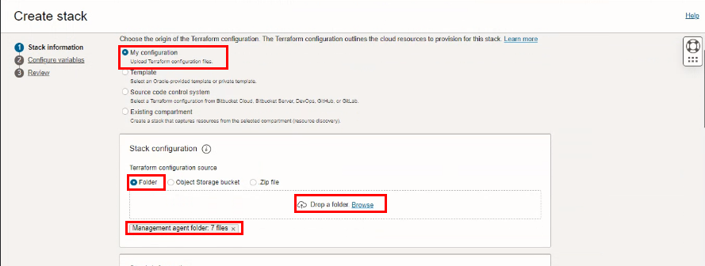

Select the parameters as per the below screen,
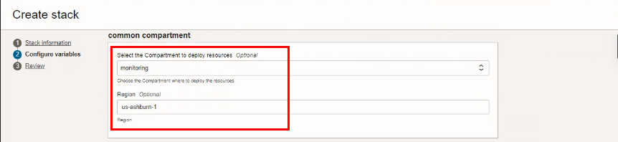

Click “NEXT”
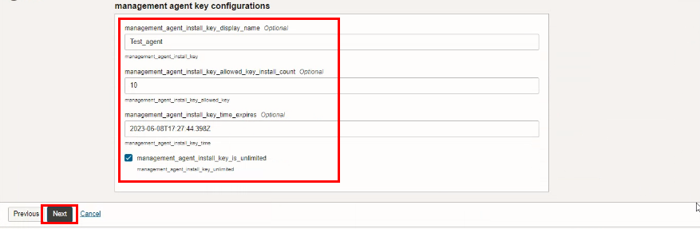

Click “CREATE”
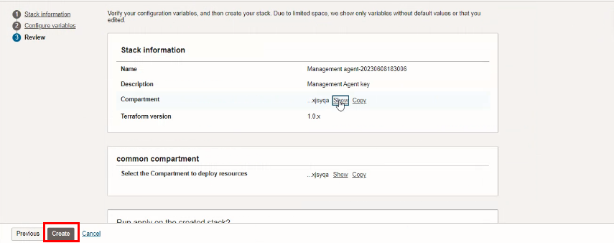

Plan the Job

Click the “Plan”
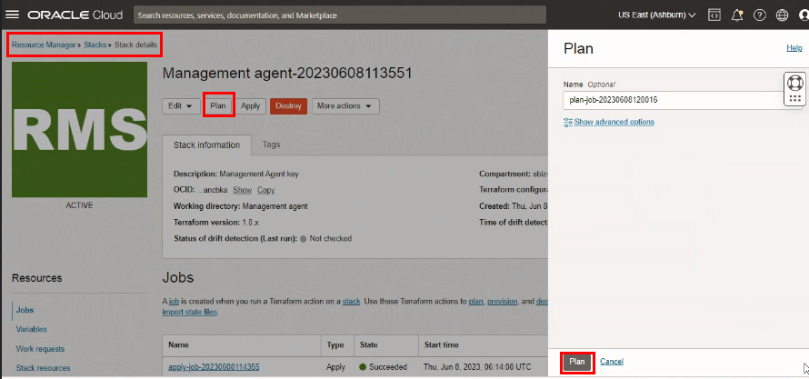

Verify the Plan is successful.
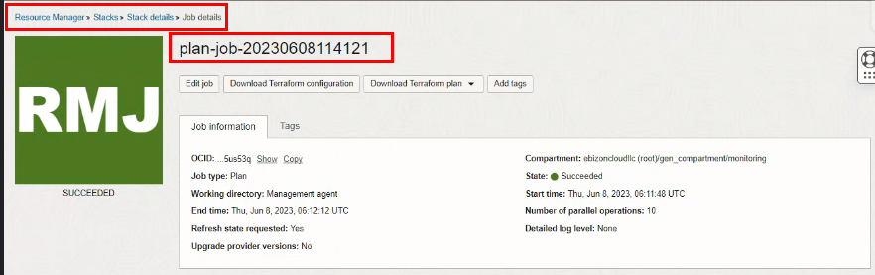
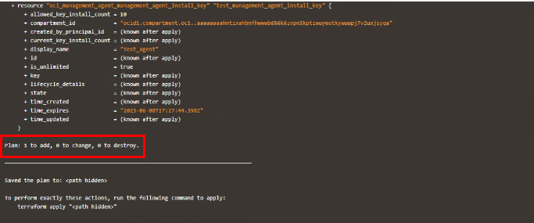

Apply the Job

Once the “plan” is success, now click “Apply”

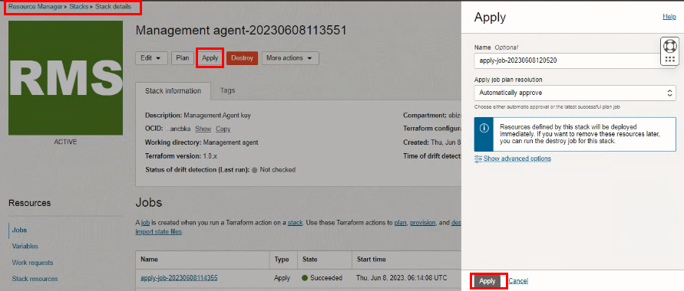

Verify the Apply is successful.
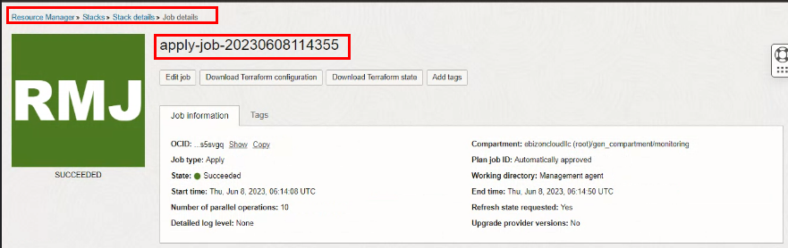
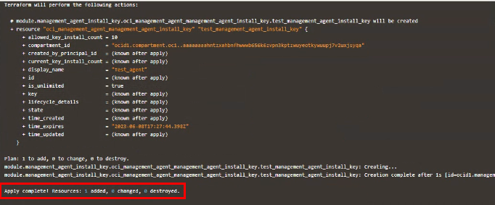

Verify in the Console

Go to OCI Console Observability & Management Management AgentDownloads and Keys

Select the specified compartment
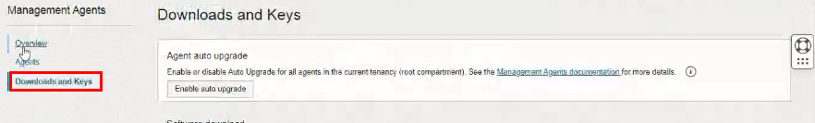

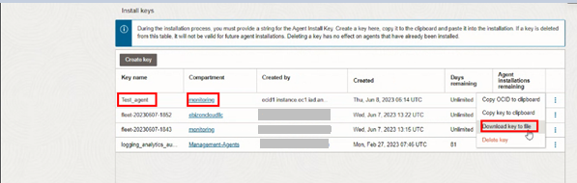

Downloaded Management Agent Key

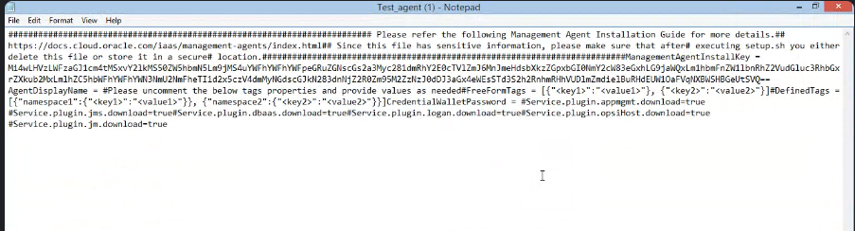

Destroy the stack

Create a destroy job in Resource Manager to release resources associated with a stack and clean up the tenancy. Once destroyed data cannot be recovered from resources.

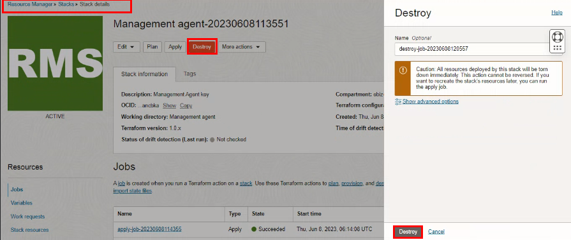

#END#

